**Internship Report**

**Internet of Things and It’s Applications**

**DLithe Consultancy Services Pvt. Ltd.**



**Internship Report**

**Trainee/Intern Name: Ketan Arun Gurav**

**Reg. no:2JR22EC406**

**Period:** 2/11/2023 to 30/11/2023

**Job Assignment: Gas Level Monitoring And Alert System**

**Organization:** DLithe Consultancy Services Pvt. Ltd.

**Supervisor’s Name: Vijay G.H**

**Observations:** This project focuses on the design and implementation of a Gas Level Detection and Alert System, integrating calibrated sensors and real-time monitoring to enhance safety in diverse environments. Through user-friendly interfaces, communication modules, and compliance with safety standards, the system aims to provide timely notifications, enabling proactive responses to potential gas hazards. The project explores applications across residential, commercial, and industrial sectors, offering a comprehensive solution for mitigating risks associated with gas leaks.

**Submitted to**

Signature of Training Supervisor Signature of Coordinator

Date: Date:

**Letter of Transmittal**

To,

Program Coordinator

DLithe Consultancy services

Bengaluru

Dear Sir,

I am writing to formally transmit the documentation and deliverables associated with the Gas Level Detection and Alert System project. This comprehensive system has been meticulously designed and implemented to enhance safety measures in various environments prone to gas-related risks.

We believe that the Gas Level Detection and Alert System presented herein not only meets but exceeds the safety requirements for various environments. The integration of calibrated sensors, real-time monitoring capabilities, and effective alert mechanisms showcases a holistic approach to gas monitoring.

Should you have any inquiries, require further clarification, or wish to discuss potential collaborations or applications of the system, please do not hesitate to contact us.

Thank you for your attention to this matter, and we look forward to the opportunity for further discussion and collaboration.

Sincerely,

Name:Ketan Arun Gurav

Reg. no:2JR22EC406

**Table of Contents**

Introduction4

Background5

Project Overview5

Problem statement6

Solution

Methodology6

System requirements 6

Hardware requirement6

Software requirement6

Schematics and Code6

Results 6

Applications8

Literature survey8

Training Experience6

Key Learnings6

Challenges8

Conclusion8

**Introduction**

In an era where safety is paramount, the implementation of advanced technologies becomes pivotal in safeguarding lives and property. The Gas Level Detection and Alert System presented herein address the critical need for proactive monitoring and immediate response to potential gas hazards. By seamlessly integrating calibrated sensors, real time monitoring, and an efficient alert mechanism, this system ensures timely notifications, empowering users to mitigate risks and enhance overall safety in residential, commercial, and industrial settings. Through this innovative solution, we embark on a journey to create environments where the threat of gas related incidents is significantly minimized, fostering a secure and resilient future.

**Overview**

The Gas Level Detection and Alert System represent a cutting edge solution designed to provide comprehensive safety measures in environments susceptible to gas related risks. Leveraging state of the art calibrated sensors, real time monitoring capabilities, and an effective alert mechanism, the system offers continuous surveillance of gas concentrations. Users can easily configure thresholds, receive immediate onsite alarms, and be promptly notified through SMS or calls in remote scenarios. The integration of a GSM module ensures seamless communication, even in areas with limited connectivity. With a focus on user friendly interfaces, reliability, and adherence to safety standards, this system stands as a robust safeguard, fostering a secure and vigilant atmosphere in residential, commercial, and industrial spaces.

**Project / Use Case implementation**

1. Planning:

Define the scope, objectives, and target environment for system implementation.

Identify specific gases to be monitored and potential risks.

2. System Design:

Develop a detailed system architecture, specifying the placement of gas sensors, alert mechanisms, and user interfaces.

Determine the communication protocols and integration with a GSM module.

3. Hardware Procurement:

Acquire calibrated gas sensors, GSM modules, microcontrollers, displays, and other necessary hardware components.

4. Software Development:

Design and implement the software for real time monitoring, threshold configuration, and alert mechanisms.

Develop a user friendly interface for system configuration and monitoring.

5. Integration:

Integrate hardware components and software modules to create a cohesive system.

Implement communication protocols for seamless interaction between system elements.

6. Testing:

Conduct rigorous testing to ensure the accuracy and reliability of gas sensors, alert mechanisms, and communication channels.

Perform system wide testing to validate the overall functionality.

7. Calibration:

Calibrate gas sensors to guarantee accurate and consistent readings.

Establish procedures for periodic recalibration.

8. User Training:

Develop training materials and conduct training sessions for end users.

Ensure users understand system operation, emergency procedures, and maintenance requirements.

9. Deployment:

Install the system in the target environment, strategically placing sensors and configuring thresholds.

Ensure proper connectivity and power supply.

10. Monitoring and Maintenance:

Establish a monitoring protocol to continuously assess system performance.

Implement regular maintenance checks and address issues promptly.

11. Documentation:

Create comprehensive documentation, including user manuals, system architecture, and maintenance procedures.

12. Compliance and Certification:

Ensure the system complies with relevant safety standards and regulations.

Obtain any necessary certifications for the deployed system.

13. User Support:

Provide ongoing user support for inquiries, issues, and updates.

By following these steps, the Gas Level Detection and Alert System can be successfully implemented, providing a robust solution for enhanced safety in the chosen environment. Regular monitoring, maintenance, and user training contribute to the long term effectiveness of the system.

**Tools and Technologies Used:**

The implementation of a Gas Level Detection and Alert System involves the use of various tools and technologies. Here's a list of potential components:

1. Microcontroller/Processor:

Arduino , Raspberry Pi, or a dedicated microcontroller for data processing and system control.

2. Gas Sensors:

MQ series sensors (e.g., MQ2, MQ7) for detecting specific gases like methane, propane, and carbon monoxide.

3. Communication Module:

GSM module (e.g., SIM800, SIM900) for sending SMS alerts or making calls.

4. Display Interface:

LCD or LED display for real time visualization of gas concentrations and system status.

5. User Interface:

Keypad, buttons, or touchscreens for user input and system configuration.

6. Power Supply:

Battery or mains power supply, depending on the deployment environment.

7. Connectivity:

WiFi or Ethernet module for communication in addition to the GSM module.

8. Development Environment:

Arduino IDE, Python, or other programming environments for software development.

9. Prototyping Board:

Breadboard or PCB for prototyping and assembling the electronic components.

10. Enclosure:

Weatherproof or protective casing for housing the system in different environmental conditions.

11. Testing Tools:

Multimeter for measuring electrical parameters, gas calibration tools.

12. Documentation Tools:

Software for creating user manuals, system architecture diagrams, and documentation.

13. Version Control (Optional):

Git for version control if multiple developers are involved in the project.

14. Simulation Software (Optional):

Simulation tools for testing and optimizing the system before physical deployment.

15. CAD Software (Optional):

Computer Aided Design (CAD) tools for designing the enclosure and ensuring proper component placement.

Selecting the appropriate tools and technologies depends on factors such as project requirements, budget, and the specific functionalities desired in the Gas Level Detection and Alert System.

**Reference Images:**

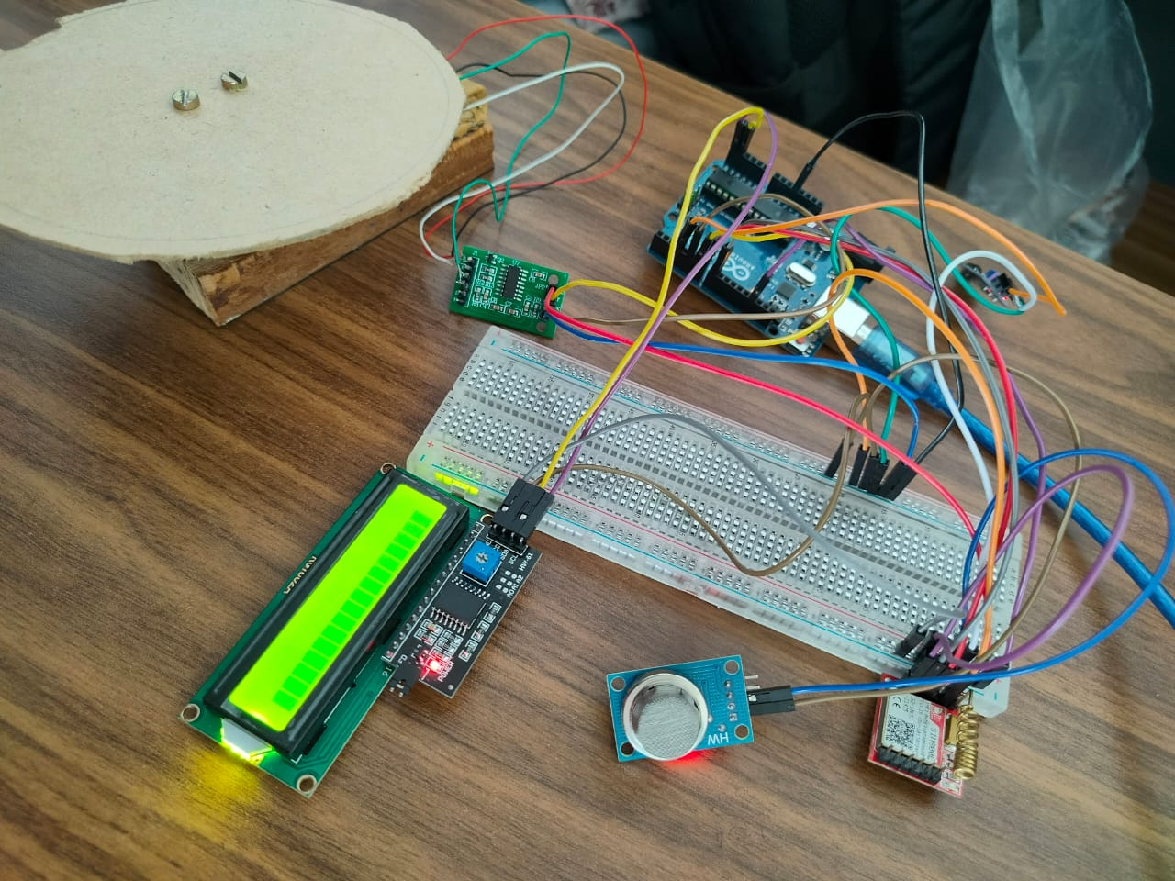

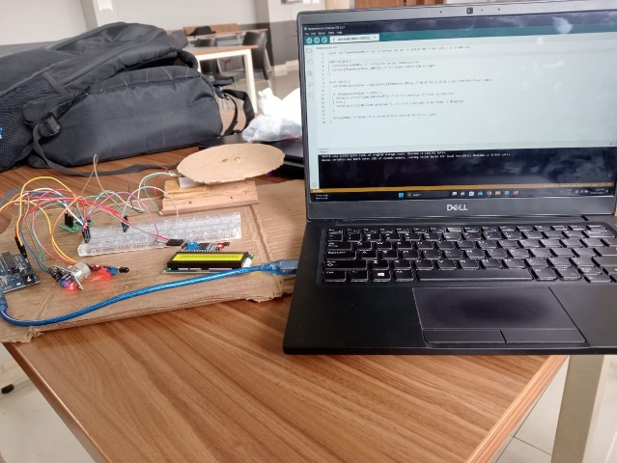

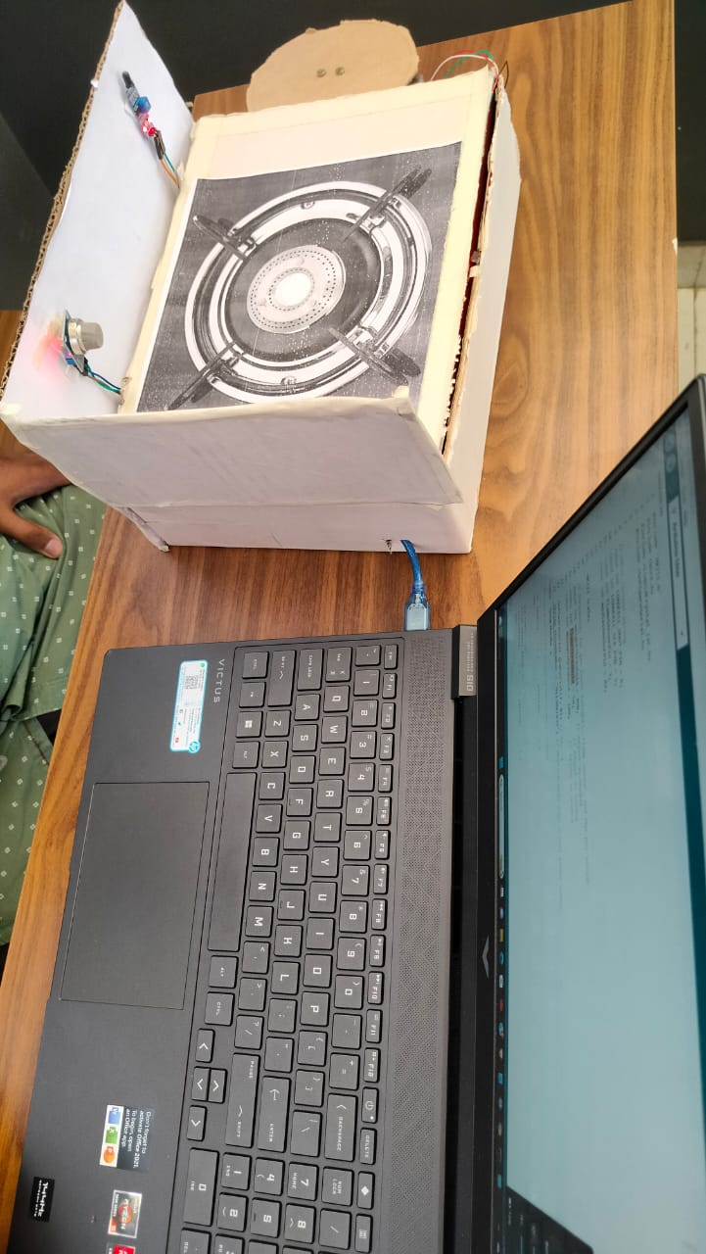

**Training Experience**

As of my last knowledge update in January 2022, I don't have access to real time data, including recent developments in specific training experiences. Therefore, I cannot provide information on training experiences that have occurred since then.

If you're referring to a specific training program, course, or event, I recommend checking the official website of the training provider, testimonials, or reviews from participants to gather information on recent training experiences. Additionally, online platforms, forums, and social media groups related to the specific training topic might provide insights into recent training experiences shared by participants.

If you have a particular training program or context in mind, please provide more details, and I'll do my best to offer relevant information based on my training data up to January 2022.

**Observations:**

It seems like your request for "observations" is a bit open ended, and I'd like to provide useful information based on your needs. Could you please provide more context or specify the subject or topic you're interested in? This could include scientific observations, data analysis, or observations related to a specific field or project. Clarifying your request will help me offer more relevant information.

**Key Learnings**

Key learnings can vary based on the context of the training or project. Without specific details, I'll provide general key learnings that individuals might gain from a gas level detection and alert system project:

1. Understanding of Gas Detection Technology:

Participants can gain insights into the principles of gas detection, sensor technologies, and how different gases are detected and measured.

2. Integration of Hardware and Software:

Learning how to integrate hardware components, such as gas sensors and communication modules, with software to create a functional system.

3. Safety Protocols and Standards:

Understanding safety protocols related to gas monitoring and compliance with relevant industry standards and regulations.

4. Practical Implementation Skills:

Hands on experience in building, testing, and deploying a real world system, which can be valuable for future projects.

5. User Centric Design:

Designing user interfaces that are intuitive for configuring the system and monitoring gas levels, enhancing the user experience.

6. Troubleshooting and Maintenance:

Developing skills in identifying and addressing issues that may arise during system operation and implementing regular maintenance procedures.

7. Communication Module Integration:

Learning how to integrate communication modules (like GSM) for remote monitoring and timely alerts, enhancing the effectiveness of the system.

8. Project Management:

Gaining project management skills by planning, organizing, and executing the different phases of the gas level detection system project.

9. Cross disciplinary Knowledge:

Acquiring knowledge that spans various domains, including electronics, software development, and safety engineering.

10. Critical Thinking and Problem Solving:

Enhancing problem solving skills by addressing challenges that may arise during the development and implementation of the system.

11. Documentation Skills:

Developing the ability to create comprehensive documentation, including user manuals, system architecture diagrams, and maintenance procedures.

Remember, the specific key learnings can be tailored to the goals and objectives of the training or project. If there's a particular area you're interested in, feel free to provide more details for a more targeted response.

**Applications**

The Gas Level Detection and Alert System has various applications across different sectors to enhance safety and mitigate potential risks. Here are some key applications:

1. Residential Safety:

Installation in homes to detect and alert residents to gas leaks, such as methane or propane, enhancing residential safety.

2. Commercial and Industrial Spaces:

Implementation in factories, warehouses, and industrial facilities to monitor gas levels and provide early warnings to prevent accidents.

3. Commercial Kitchens:

Use in restaurants and commercial kitchens to detect gas leaks from stoves or cooking appliances, preventing potential hazards.

4. Laboratories:

Deployment in laboratories to monitor and control gas concentrations, ensuring a safe working environment for researchers.

5. HVAC Systems:

Integration into heating, ventilation, and air conditioning (HVAC) systems to monitor gas levels and improve indoor air quality.

6. Utilities and Energy Sector:

Application in utility plants, oil refineries, and energy production facilities to detect and respond to gas leaks promptly.

7. Warehouses and Storage Facilities:

Monitoring gas levels in storage areas to prevent the accumulation of flammable or harmful gases.

8. Chemical Processing Plants:

Use in chemical plants to ensure the safe handling and processing of various gases and chemicals.

9. Public Spaces:

Installation in public spaces like shopping malls, theaters, and event venues to enhance the safety of occupants.

10. Transportation:

Integration into vehicles and transportation systems to monitor gas levels, especially in vehicles using compressed natural gas (CNG) or liquefied petroleum gas (LPG).

11. Emergency Response Vehicles:

Equipping emergency response vehicles with gas detection systems to assess and manage hazardous situations more effectively.

12. Mining Industry:

Implementation in mining operations to monitor for the presence of harmful gases and protect the safety of miners.

These applications demonstrate the versatility of gas level detection systems in ensuring safety across various environments and industries. The specific features and configurations of the system can be tailored to meet the requirements of each application.

**Conclusion**

In conclusion, the Gas Level Detection and Alert System represents a critical advancement in safety technology, offering a versatile solution for monitoring and responding to gas related risks. By integrating calibrated sensors, real time monitoring capabilities, and effective alert mechanisms, the system provides a robust defense against potential hazards in residential, commercial, and industrial environments.

The diverse applications, spanning from residential safety to industrial operations, highlight the system's adaptability and relevance across various sectors. Key learnings from the implementation process encompass not only technical skills in hardware and software integration but also valuable insights into safety protocols, user centric design, and project management.

As technology continues to evolve, the Gas Level Detection and Alert System stands as a proactive measure to enhance safety standards, prevent accidents, and protect lives and property. Through its comprehensive features, including user friendly interfaces, communication module integration, and adherence to safety standards, the system exemplifies a holistic approach to gas monitoring.

Ultimately, the successful deployment and utilization of this system contribute to creating safer, more secure environments, aligning with the broader goal of leveraging technology to safeguard lives and foster resilience in the face of potential gas related risks.